**EX NO.: 07 TRIGGERS**

**AIM:**

To create and work with triggers.

**PROCEDURE:**

**Step 1**: Open Run SQL on Command line and connect to SQL

**Step 2:** Then work with database using SQL queries.

**Trigger:** A trigger is a stored procedure in database which automatically invokes whenever a special event in the database occurs. For example, a trigger can be invoked when a row is inserted into a specified table or when certain table columns are being updated.

**Syntax:**

create trigger [trigger_name]

[before | after]

{insert | update | delete}

on [table_name]

[for each row]

[trigger_body]

**PROGRAM CODE:**

SQL> CREATE OR REPLACE TRIGGER set_default_salary

2 BEFORE INSERT ON employee

3 FOR EACH ROW

4 BEGIN

5 :NEW.salary := 50000;

6 END;

7 /

This trigger program creates a trigger called **set_default_salary** that fires before an insert operation is performed on the **employee** table. The trigger sets the **salary** value of the new employee being inserted to 50000.

Note that the **BEFORE INSERT** clause specifies that the trigger should fire before the insert operation is performed, and the **FOR EACH ROW** clause specifies that the trigger should execute once for each row that is inserted. Finally, the **:NEW** keyword is used to reference the values being inserted into the table.

**OUTPUT:**

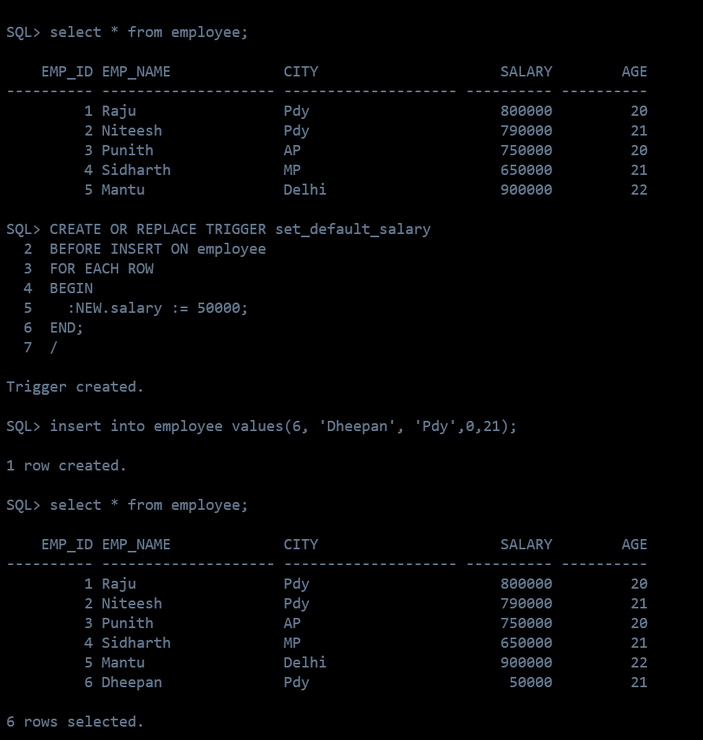

**RESULT:**

The queries for Triggers were successfully executed and the output is noted.